|  |
| --- |
| **Ministry of education and training** |
| Software Requirement Specifications |
| Exchange Online |
|  |
| |  |  | | --- | --- | |  | | | **Group Members** |  | | **Supervisor** |  | | **Ext Supervisor** |  | | **Capstone Project code** |  | |
| **Hanoi, 26th Jan, 2011** |

**Record of Changes**

|  |  |  |  |  |
| --- | --- | --- | --- | --- |
| **Date** | **Change Item** | **Description** | **By** | **Version** |
| 26/1/2011 | All | Create the document | HoaHM | 0.1 |
|  |  |  |  |  |

# Table of Contents

Table of Contents 2

I. User Requirement Specification 4

II. System Requirement Specification (Specific Requirements) 4

1. External Interface Requirements 4

2. System Features 4

2.1 View admin home page 4

2.2 Edit a Place’s Information 6

2.3 Edit a Place’s Location 12

2.4 View Edit History of a Place 16

2.5 View a Revision of a Place 19

2.6 Compare 2 Revisions of a Place 23

2.7 Approve a Revision 28

2.8 Set a revision as current 32

2.9 View a Place Detail 36

2.10 Search Places 42

2.11 Report a Place 48

2.12 Mark a Place as Visited 52

2.13 Rate a Place 54

2.14 Post a Comment 57

2.15 Delete a Comment 60

2.16 Vote a Comment 62

2.17 Highlight Best Comment 67

2.18 Report a Comment 69

2.19 Question & Answer Page 74

2.20 View Question Detail 77

2.21 Create a New Question 81

2.22 Vote a Question 85

2.23 Report a Question 89

2.24 Post an answer 93

2.25 Vote an answer 96

2.26 Report an answer 100

2.27 Delete an answer 104

2.28 View Favorite List 106

2.29 Add a Place to Favorite List 109

2.30 Remove Places from Favorite List 112

2.31 List Top Places of Month 115

2.32 List Newest Places 116

2.33 List Most Searched Categories 119

2.34 List Most Contributors 121

2.35 Log In 123

2.36 Log Out 127

2.37 Register an Account 130

2.38 Reset Forgot Password 134

2.39 Edit Your Profile 138

2.40 Change Password 143

2.41 View an User’s Profile 146

2.42 <Admin> List all Users 151

2.43 <Admin> View User Detail 154

2.44 <Admin> Edit an User 156

2.45 <Admin> Delete Users 159

2.46 <Admin> List All Categories 161

2.47 <Admin> Create a New Category 164

2.48 <Admin> Edit a Category 168

2.49 <Admin> Delete Categories 171

2.50 <Admin> List All Advertises 174

2.51 <Admin> Create New Advertise 176

2.52 <Admin> Edit an Advertise 179

2.53 <Admin> Delete Advertise 182

2.54 <Admin> Manage Reported Places 185

2.55 <Admin> Manage Reported Comments 188

2.56 <Admin> Manage Reported Questions 192

2.57 <Admin> Manage Reported Answers 195

III. References 199

# User Requirement Specification

# System Requirement Specification (Specific Requirements)

## External Interface Requirements

## System Features

### <Admin>View admin home page

#### Use Case Diagram



#### Use Case Specification

|  |  |  |  |  |
| --- | --- | --- | --- | --- |
| **USE CASE - View admin home page SPECIFICATION** | | | | |
| **Use-case No.** | UC001 | **Use-case Version** | | 1.0 |
| **Use-case Name** | View admin home page | | | |
| **Author** | HoaHM | | | |
| **Date** | 13/04/2012 | **Priority** | Normal | |
| **Actor:**  Admin  **Summary:**  After login into the website with admin role, system will redirect user to admin home page with full control and listing all of features that system has supported.This use-case also provide some statistic information and overview of backend.  **Goal:**  Allow admin to view all features for controlling system and some basic information  **Triggers**  Click on the MenuItem “Admin Home” or first time load.  **Preconditions:**  User logged into the system with admin role successfully.  **Post Conditions:**  System redirects user to the admin home page.  **Main Success Scenario:**   |  |  |  | | --- | --- | --- | | Step | Actor Action | System Response | | 1 | Login with role admin successfully | Redirect to Admin Home Page  Show all features and information |   **Relationships:**  Log in use case  **Business Rules:**  The same functions will be in same group on menu.  In the main part of home page, the page is devided into many parts.Every part will have some same functions. Every function has a small description below. | | | | |

**Screen**

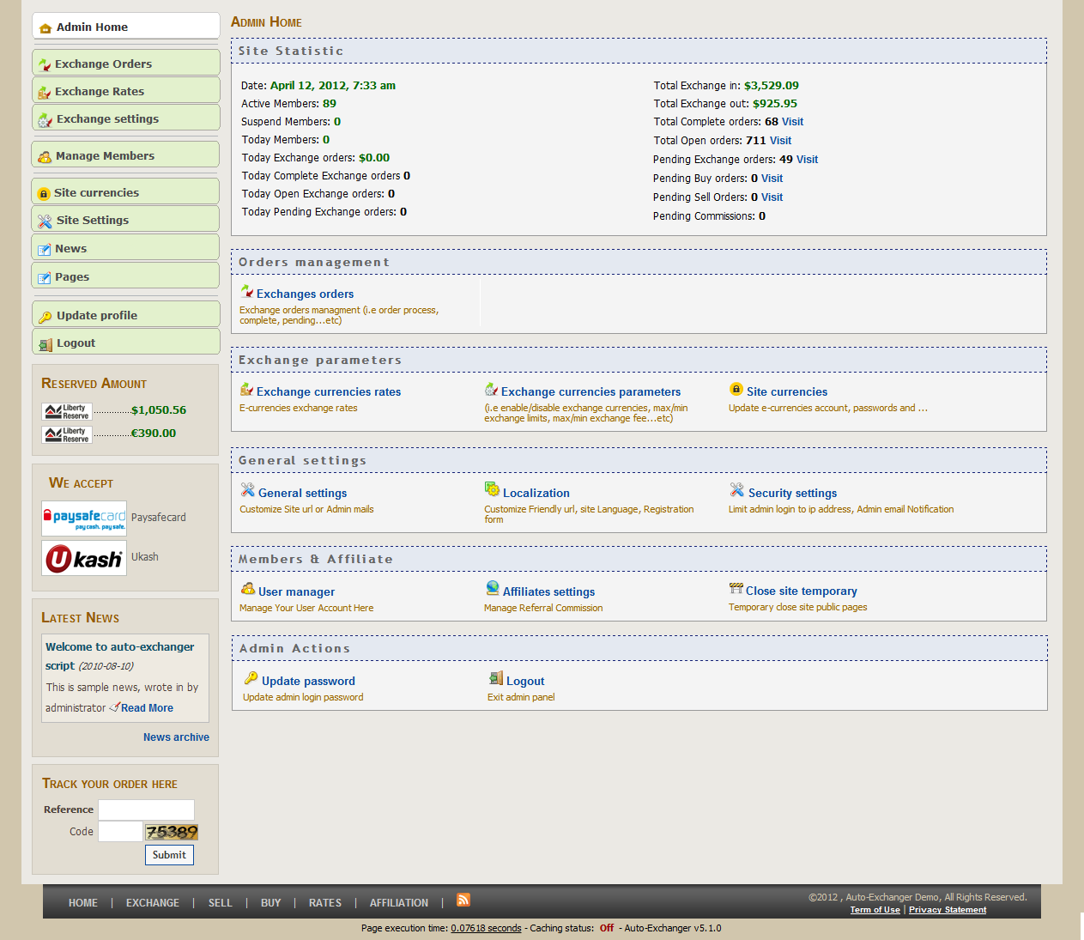

**Buttons / Hyper Links – Attach Place Page**

|  |  |  |  |  |
| --- | --- | --- | --- | --- |
| **Function** | **Description** | **Available Criteria** | **Validations** | **Outcome** |
| Exchange orders | This hyper will redirect user to Order management | Always available | No validations | Refer to Exchange Order Page |
| Exchange currencies rates | This hyper will redirect user to Exchanges Rates with updating rates function | Always available | No validations | Refer to Exchange Rates Page |
| Exchange ocurrencies parameter | This hyper will redirect user to Exchanges Settings with update all currencies and add new currency | Always available | No validations | Refer to Exchange Settings Page |
| Sites currencies rates | This hyper will redirect user to page that enable and configure the e-currencies admin wants to accept in | Always available | No validations | Refer to Manage Currencies info & passwords Page |
| General setting | This hyperlink will redirect user to page with tab Gerenal and admin can change the site url, site name… | Always available | No validations | Refer to Site Settings Page |
| Localization | This hyperlink will redirect user to page with tab Localization and admin can change language… | Always available | No validations | Refer to Site Settings Page |
| Security setting | This hyperlink will redirect user to page with tab Security and admin can change the login ip… | Always available | No validations | Refer to Site Settings Page |
| User manager | This hyperlink will redirect user to page and admin can view all user, view details of users… | Always available | No validations | Refer to Members management Page |
| Affiliates settings | This hyperlink will redirect user to page to Manage Referral Commission | Always available | No validations | Refer to Site Settings Page |
| Close site temporary | This hyperlink will redirect user to page to Temporary close site public pages | Always available | No validations | Refer to Site Settings Page |
| Update password | This hyperlink will redirect user to page to change her/his password | Always available | No validations | Refer to Update Profile |
| Log out | This hyperlink will allow for user log out from system | Always available | No validations | Refer to Home Page (default page without login) |

### <Admin>View Open Order

#### Use Case Diagram



#### Use Case Specification

|  |  |  |  |  |
| --- | --- | --- | --- | --- |
| **USE CASE- View Open Order SPECIFICATION** | | | | |
| **Use-case No.** | UC002 | **Use-case Version** | | 1.0 |
| **Use-case Name** | View Open Order | | | |
| **Author** | HoaHM | | | |
| **Date** | 13/04/2012 | **Priority** | Normal | |
| **Actor:**  Admin  **Summary:**  When the admin want system to show all the open order in the list.The list of order will be shown and the total number of orders will displayed in the bottom of list  **Goal:**  This use case allows admin view all of information of open order  **Triggers**  Click on the “Exchanges Orders” menu item or “Exchanges Orders” hyperlink  **Preconditions:**  Logged into the system successfully and open the admin home pages.  **Post Conditions:**  Redirected to Exchange orders Pending page  **Main Success Scenario:**   |  |  |  | | --- | --- | --- | | Step | Actor Action | System Response | | 1 | Admin click on the “Exchanges Orders” menu item | System displays Exchange Order Pending |   **Alternative Scenario:**   |  |  |  | | --- | --- | --- | | Step | Actor Action | System Response | | 1 | Admin click on the “Exchanges Orders” hyperlink | System displays Exchange Order Pending |     **Relationships:**  Log in use case, View admin home page use case  **Business Rules:**   |  |  |  | | --- | --- | --- | |  | Business Rule | Error Message | | 1 | Display only the the order with have status “Open” |  | | 2 | In the case there’s no have “Open Orders” | No Open Orders found. | | | | | |

**Screen**

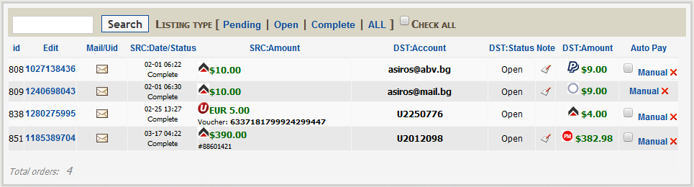

### <Admin>Search Order

#### Use Case Diagram



#### Use Case Specification

|  |  |  |  |  |
| --- | --- | --- | --- | --- |
| **USE CASE- Search Order SPECIFICATION** | | | | |
| **Use-case No.** | UC003 | **Use-case Version** | | 1.0 |
| **Use-case Name** | Search Order | | | |
| **Author** | HoaHM | | | |
| **Date** | 13/04/2012 | **Priority** | Normal | |
| **Actor:**  Admin  **Summary:**  When the information become very large and the admin cannot see exactly one orders.So the search function will helps the admin narrow the result.  **Goal:**  This use case allows the actor edit the location of the place on Google map.  **Triggers**  Click to “Vị trí không chính xác?” hyperlink in Place Detail page.  **Preconditions:**  Logged into the system successfully and open Place Detail page  **Post Conditions:**  The location of the place is changed on Google map and the user stays in Place Detail page  **Main Success Scenario:**   |  |  |  | | --- | --- | --- | | Step | Actor Action | System Response | | 1 | User click to “Vị trí không chính xác?” hyperlink | Popup a map displaying place current location | | 2 | User choose place’s location on displayedmap | A symbol marks the location user choose | | 3 | User click to “Cập nhật” button | System save location and closes the popup. |   **Alternative Scenario:**   |  |  |  | | --- | --- | --- | | Step | Actor Action | System Response | | 1 | User click to “Vị trí không chính xác?” hyperlink | Popup a mapdisplaying place current location | | 2 | User click to “Bỏ qua” button | System closes the popup |   **Exceptions:**  None  **Relationships:**  Log in use case, View place detail use case, Edit place’s information use case  **Business Rules:**   |  |  |  | | --- | --- | --- | |  | Business Rule | Error Mesage | | 1 | Rank of an user will be set based on the user’s contribution point (CP) |  | | 2 | Contribution Point (CP) is calculated as follow: **-** Starter point for every user is 10 point - Create a place: + 20 point - Your place get deleted: - 25 point |  | | 3 | For user has more than 1000 point (senior user): - Can edit a place directly - Can upload place’s image directly - Can approve suggested edit - Can approve suggested images  - Set a revision as current |  | | 4 | For user has less than 1000 point (junior user): - an revision of a place created by these users need approvals from senior users or admins to be displayed | “Bạn chưa đủ điểm để sử dụng chức năng này” | | | | | |
| **Description:**  This function is used when users want to change place location only. It’s quick and save time. Users only need click to “Vị trí không chính xác?” hyperlink, click to new location at popup map and click to “Cập nhật” button. Place location will be replaced by new one.  Location changing made by verified users (>= 1000 point) will take effect right away but the ones made by normal users (< 100 point) will be take in consider. | | | | |

**Screen**

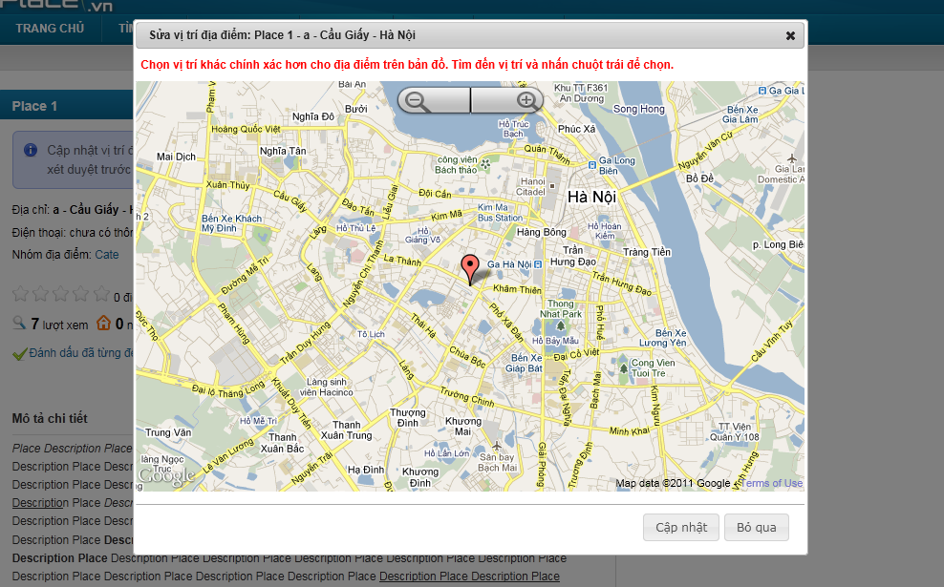

**Data Fields Definition – Attach Place Page**

|  |  |  |  |  |  |  |
| --- | --- | --- | --- | --- | --- | --- |
| **Field name** | **Description** | **Read**  **Only** | **Mandatory** | **Control Type** | **Data Type** | **Length** |
| Map title | A title with content: “Sửa vị trí địa điểm:” + place name + ”-” + detail address + “-” + place’s district/town/ward + “-” + place’s city/province | N/A | N/A | Label | Text | Fixed |
| Map label | A label with content “**Chọn vị trí khác chính xác hơn cho địa điểm trên bản đồ. Tìm đến vị trí và nhấn chuột trái để chọn.**” | N/A | N/A | Label | Text | Fixed |

**Buttons / Hyper Links – Attach Place Page**

|  |  |  |  |  |
| --- | --- | --- | --- | --- |
| **Function** | **Description** | **Available Criteria** | **Validations** | **Outcome** |
| Save new location | The button will allow the user to save the place’s location. | Always available | No | New location is saved, popup is closed |
| cancel | The button will allow the user to close this popup | Always available | No | Pop up window will be closed |

### <Admin>Filter Order (Listing type)

#### Use Case Diagram



#### Use Case Specification

|  |  |  |  |  |
| --- | --- | --- | --- | --- |
| **USE CASE- View edit history of a place SPECIFICATION** | | | | |
| **Use-case No.** | UC004 | **Use-case Version** | | 1.0 |
| **Use-case Name** | View edit history of a place | | | |
| **Author** | HoaHM | | | |
| **Date** | 13/04/2012 | **Priority** | Normal | |
| **Actor:**  User  **Summary:**  This use case allows the actor track the changed history of a place from created time to current time.  **Goal:**  Display the edit history of a place  **Triggers**  Click to “Xem lịch sử sửa đổi” button in the place’s details page  **Preconditions:**  User is in the place’s details page.  **Post Conditions:**  Display edit history page  **Main Success Scenario:**   |  |  |  | | --- | --- | --- | | Step | Actor Action | System Response | | 1 | User click to “Xem lịch sử sửa đổi” hyperlink | System displays the edit history page |   **Exceptions:**  None  **Relationships:**  View place use case  **Business Rules:**  None | | | | |
| **Description:**  Because users can edit place information, functions to keep track and control all the changes become essential. Everyone can see change history of places by click to “Xem lịch sử sửa đổi” at Place Detail page. This page will display every change, users who made these changes and what type of changes they are.  Each time a place was edited, a new version of that place was born. We call these versions “Revision”. Users can compare 2 revisions to see what has changed from this revision to other revision. All users need is check 2 revisions and click to “So sánh” button.  In all revisions, only 1 revision is set as current revision. This revision will be used to display at Place Detail page. In revision list, current revision has “(*)” sign beside its name.  Revisions created by verified users (>= 1000 point) will be set as current revision right away it was created. But revisions created by users with lesser point will be displayed in gray at revision list. These revisions need approvals from verified users or admin to become a truly revision. If a revision was disapproved, it will be strikethrough and displayed in red.  At Edit history page, users can go back to Place Detail page by clicking to “Quay lại trang địa điểm” hyperlink or go to Edit Place page by clicking to “Chỉnh sửa thông tin” hyperlink. | | | | |

**Screen**

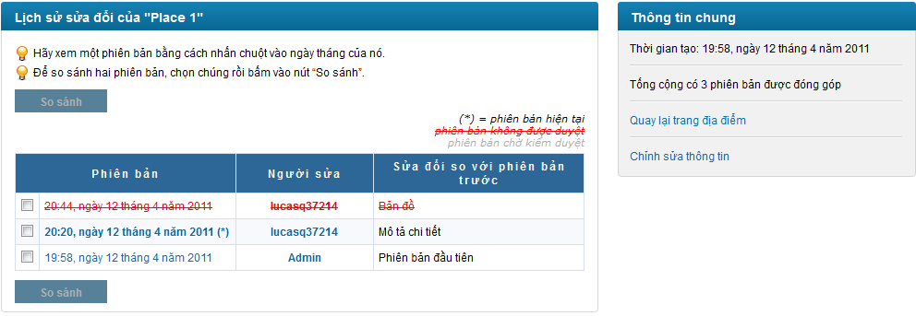

**Data Fields Definition – Attach Place Page**

|  |  |  |  |  |  |  |
| --- | --- | --- | --- | --- | --- | --- |
| **Field name** | **Description** | **Read**  **Only** | **Mandatory** | **Control Type** | **Data Type** | **Length** |
| **Revision area** | **The following fields will be surrounded by a border to allow logical grouping of data for the user. The border will have a heading titled “Lịch sử sửa đổi của” + place name** | **N/A** | **N/A** | **Group Box** | **Text** | **Fixed** |
| Instruction | Contains instructions for viewing and compare revisions | N/A | N/A | Label | Label | Fixed |
| Revisions | A grid with 3 columns: “Phiên bản”, “Người sửa” and “sửa đổi so với phiên bản trước” | N/A | N/A | Label | Text | Fixed |
| **General information** | **The following fields will be surrounded by a border to allow logical grouping of data for the user. The border will have a heading titled “Thông tin chung”** | **N/A** | **N/A** | **Group Box** | **Text** | **Fixed** |
| Place created date | A label with content “Thời gian tạo:” + created date in vietnamese | N/A | N/A | Label | Label | Fixed |
| Revision number | A label with content “Tống cộng có” + revision number +“phiên bản được đóng góp” | N/A | N/A | Label | Label | Fixed |

**Buttons / Hyper Links – Attach Place Page**

|  |  |  |  |  |
| --- | --- | --- | --- | --- |
| **Function** | **Description** | **Available Criteria** | **Validations** | **Outcome** |
| Compare 2 revision | The button will allow the user to compare 2 edit versions. | Disable by default.  Enable when only 2 versions are selected | No validation | User is navigated to the version compare page |
| Revision hyperlink | The date time that the edit version is saved.  Open the edit version’s details page | Always available | No validation | display chosen edit version’s details in popup |
| Creator hyperlink | The username of the user that created this revision is displayed as hyperlink. | Always available | No validation | Redirect to user profile page |
| Edit page hyperlink | “[Quay lại trang địa điểm](http://localhost:2470/dia-diem/place-1-1)” hyperlink | Always available | No validation | Redirect user to Edit Place page |
| Detail page hyperlink | “[Chỉnh sửa thông tin](http://localhost:2470/places/edit/1)” hyperlink | Always available | No validation | Redirect user back to Place Detail page |

### <Admin>Delete Order

#### Use Case Diagram



#### Use Case Specification

|  |  |  |  |  |
| --- | --- | --- | --- | --- |
| **USE CASE- View a revision of a place SPECIFICATION** | | | | |
| **Use-case No.** | UC005 | **Use-case Version** | | 1.0 |
| **Use-case Name** | View a revision of a place | | | |
| **Author** | HoaHM | | | |
| **Date** | 13/04/2012 | **Priority** | Normal | |
| **Actor:**  User  **Summary:**  This use case allows the actor view in detail a revision of a place.  **Goal:**  Display detail information of a revision of a place  **Triggers**  Click to the revision name hyperlink  **Preconditions:**  User is in the history page.  **Post Conditions:**  Popup a window to display revision detail  **Main Success Scenario:**   |  |  |  | | --- | --- | --- | | Step | Actor Action | System Response | | 1 | User click to revision hyperlink | Popup a window to display revision detail |   **Exceptions:**  None  **Relationships:**  Log in use case, View history of a place use case  **Business Rules:**  None | | | | |
| **Description:**  Revisions created by users with less than 1000 points will be taken in consideration. Approvals from verified users (has 1000 points or more) and admins will make it become a real revision and can be displayed at Place Detail page. At Edit history page, when users click to a Revision, a popup will open and displayed all information of that revision. Revision’s information is not different with a place’s information. It has addition information that is State. State will let people know that the current viewing revision is in need of approvals or not. | | | | |

**Screen**

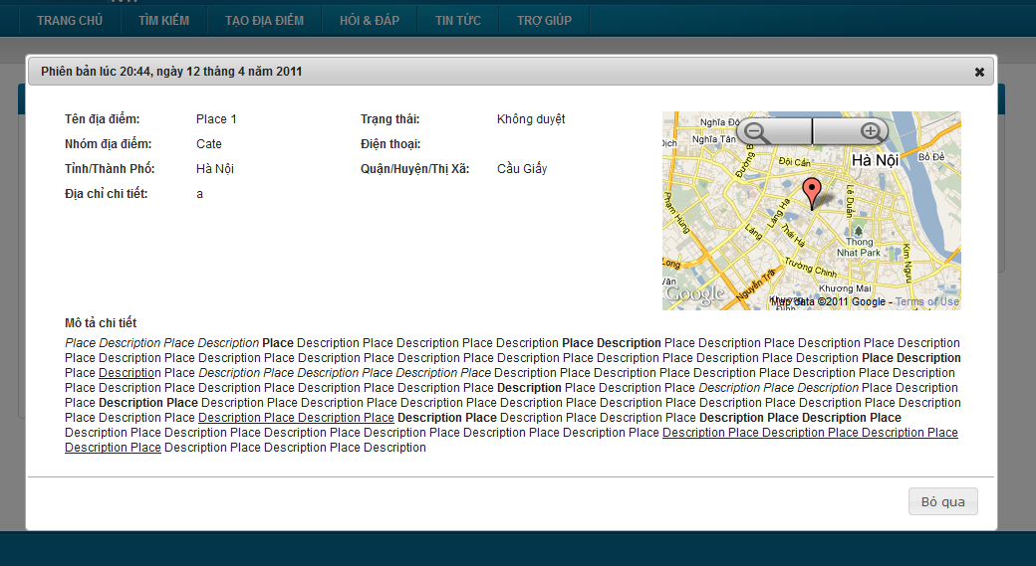

**Data Fields Definition – Attach Place Page**

|  |  |  |  |  |  |  |
| --- | --- | --- | --- | --- | --- | --- |
| **Field name** | **Description** | **Read**  **Only** | **Mandatory** | **Control Type** | **Data Type** | **Length** |
| **Basic information** | **The following fields will be surrounded by a border to allow logical grouping of data for the user. The border will have a heading titled “Phiên bản” + created date in vietnamese** | **N/A** | **N/A** | **Group Box** | **Text** | **Fixed** |
| Place name label | A label with content “Tên địa điểm” | N/A | N/A | Label | Text | Fixed |
| Place name | Place name | N/A | N/A | Label | Text | Fixed |
| Revision state label | A label with content “Trạng thái” | N/A | N/A | Label | Text | Fixed |
| Revision state | Revision state | N/A | N/A | Label | Text | Fixed |
| Category label | A label with content “Nhóm địa điểm” | N/A | N/A | Label | Text | Fixed |
| Category | Place’s category | N/A | N/A | Label | Text | Fixed |
| City label | A label with content “Tỉnh / Thành Phố” | N/A | N/A | Label | Text | Fixed |
| City | Place’s city/province | N/A | N/A | Label | Text | Fixed |
| District label | A label with content “Quận / Huyện/Thị xã” | N/A | N/A | Label | Text | Fixed |
| District | Place’s district/town/ward | N/A | N/A | label | Text | Fixed |
| Phone number label | A label with content “Điện thoại” | N/A | N/A | Label | Text | Fixed |
| Phone number | Place’s phone number | N/A | N/A | Label | Text | Fixed |
| Detail address label | A label with content “Địa chỉ chi tiết” | N/A | N/A | Label | Text | Fixed |
| Detail address | Place’s detail address | N/A | N/A | Label | Text | Fixed |
| **Mini map** | **A mini map display place location** | N/A | N/A | **Google Map API** |  |  |
| **Detail description** | **The following fields will be surrounded by a border to allow logical grouping of data for the user. The border will have a heading titled “Mô tả chi tiết”** | **N/A** | **N/A** | **Group Box** | **Text** | Fixed |
| Description box | Place’s description | N/A | N/A | Label | Text | Fixed |

**Buttons / Hyper Links – Attach Place Page**

|  |  |  |  |  |
| --- | --- | --- | --- | --- |
| **Function** | **Description** | **Available Criteria** | **Validations** | **Outcome** |
| Cancel | This button is for closing popup | Always available | No validation | Close the popup |

### <Admin>Edit Order

#### Use Case Diagram



#### Use Case Specification

|  |  |  |  |  |
| --- | --- | --- | --- | --- |
| **USE CASE- Compare 2 revisions of a place SPECIFICATION** | | | | |
| **Use-case No.** | UC006 | **Use-case Version** | | 1.0 |
| **Use-case Name** | Compare 2 revisions of a place | | | |
| **Author** | HoaHM | | | |
| **Date** | 13/04/2012 | **Priority** | Normal | |
| **Actor:**  User  **Summary:**  This use case allows the user compare 2 edit revision of a place and spot differences.  **Goal:**  Display comparison result of 2 revisions  **Triggers**  Click to the “So sánh” button in the edit history page  **Preconditions:**  User is in the edit history page.  **Post Conditions:**  Compare result is displayed  **Main Success Scenario:**   |  |  |  | | --- | --- | --- | | Step | Actor Action | System Response | | 1 | User click to 2 check boxes of 2 revisions | The “So sánh” button is enabled | | 2 | User click to “So sánh” button | System redirect user to compare revision page |   **Exceptions:**  None  **Relationships:**  Log in use case, View a place detail, Views history of a place use case  **Business Rules:**   |  |  |  | | --- | --- | --- | |  | Business Rule | Error Message | | 1 | Only compare 2 revisions |  | | 2 | Date fields contains differences is displayed in red background |  | | | | | |
| **Description:**  At Edit history page, users can compare 2 revisions by check these 2 revisions and click to “So sánh” button. A popup will open and display compares result. These results contain information of 2 revisions. The differences are displayed in red. About place location, the system only let users know if there is difference or not. | | | | |

**Screen**

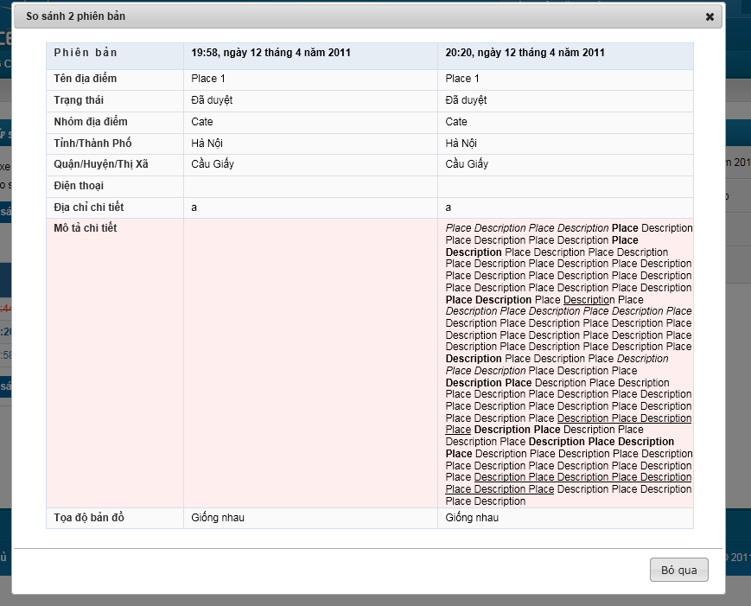

**Data Fields Definition – Attach Place Page**

|  |  |  |  |  |  |  |
| --- | --- | --- | --- | --- | --- | --- |
| **Field name** | **Description** | **Read**  **Only** | **Mandatory** | **Control Type** | **Data Type** | **Length** |
| Place name label | A label with content “Tên địa điểm” | N/A | N/A | Label | Text | Fixed |
| Place name | Place name | N/A | N/A | Label | Text | Fixed |
| Revision state label | A label with content “Trạng thái” | N/A | N/A | Label | Text | Fixed |
| Revision state | Revision state | N/A | N/A | Label | Text | Fixed |
| Category label | A label with content “Nhóm địa điểm” | N/A | N/A | Label | Text | Fixed |
| Category | Place’s category | N/A | N/A | Label | Text | Fixed |
| City label | A label with content “Tỉnh / Thành Phố” | N/A | N/A | Label | Text | Fixed |
| City | Place’s city/province | N/A | N/A | Label | Text | Fixed |
| District label | A label with content “Quận / Huyện/Thị xã” | N/A | N/A | Label | Text | Fixed |
| District | Place’s district/town/ward | N/A | N/A | label | Text | Fixed |
| Phone number label | A label with content “Điện thoại” | N/A | N/A | Label | Text | Fixed |
| Phone number | Place’s phone number | N/A | N/A | Label | Text | Fixed |
| Detail address label | A label with content “Địa chỉ chi tiết” | N/A | N/A | Label | Text | Fixed |
| Detail address | Place’s detail address | N/A | N/A | Label | Text | Fixed |
| Description label | A label with content “Mô tả chi tiết” | N/A | N/A | Label | Text | Fixed |
| Description box | Place’s description | N/A | N/A | Label | Text | Fixed |
| Place location label | A label with content “Toạ độ bản đồ” | N/A | N/A | Label | Text | Fixed |
| Place location | “Giống nhau” or “Khác nhau” label | N/A | N/A | Label | Text | Fixed |

**Buttons / Hyper Links – Attach Place Page**

|  |  |  |  |  |
| --- | --- | --- | --- | --- |
| **Function** | **Description** | **Available Criteria** | **Validations** | **Outcome** |
| Cancel | This button is for closing popup | Always available | No validation | Close the popup |

### <Admin>Manually Pay Out

#### Use Case Diagram



#### Use Case Specification

|  |  |  |  |  |
| --- | --- | --- | --- | --- |
| **USE CASE- Approve a version SPECIFICATION** | | | | |
| **Use-case No.** | UC007 | **Use-case Version** | | 1.0 |
| **Use-case Name** | Approve a revision | | | |
| **Author** | HoaHM | | | |
| **Date** | 13/04/2012 | **Priority** | Normal | |
| **Actor:**  Senior user (with more than 1000 Contribution Point) or Administrations (View more Business rules for detail)  **Summary:**  Revisions created by junior user won’t be set as current revision. It needs approval to be displayed. Senior users and admins can approve or disapprove revisions when viewing revision detail.  **Goal:**  Approve or disapprove a revision  **Triggers**  Click to “Duyệt sửa đổi” button or “Không duyệt sửa đổi” button at Revision Detail popup  **Preconditions:**  Logged into the system successful and open a revision’s details popup.  **Post Conditions:**  Update revision state and still stay at Edit history Page  **Main Success Scenario:**   |  |  |  | | --- | --- | --- | | Step | Actor Action | System Response | | 1 | Click to “Duyệt sửa đổi” button | Popup closes, revision state is changed to approved |   **Alternative Scenarios:**   |  |  |  | | --- | --- | --- | | Step | Actor Action | System Response | | 1 | Click to “Không duyệt sửa đổi” button | Popup closes, revision state is changed to disapproved |  |  |  |  | | --- | --- | --- | | Step | Actor Action | System esponse | | 1 | Click to “Bỏ qua” button | Popup closes |   **Exceptions:**  None  **Relationships:**  Log in use case, Views edit history of a place, view a revision use case.  **Business Rules:**   |  |  |  | | --- | --- | --- | |  | Business Rule | Error Message | | 1 | Rank of an user will be set based on th user’s contribution point (CP) |  | | 2 | Contribution Point (CP) is calculated as follow: **-** Starter point for every user is 10 point - Create a place: + 20 point - Your place get deleted: - 25 point |  | | 3 | For user has more than 1000 point (senior user): - Can edit a place directly - Can upload place’s image directly - Can approve suggested edit - Can approve suggested images  - Set a revision as current |  | | 4 | For user has less than 1000 point (junior user): - an revision of a place created by these users need approvals from senior users or admins to be displayed | “Bạn chưa đủ điểm để sử dụng chức năng này” | | | | | |
| **Description:**  Revisions created by users with less than 1000 points will be taken in consideration. Approvals from verified users (has 1000 points or more) and admins will make it become a real revision and can be displayed at Place Detail page. At Edit history page, when users click to a Revision, a popup will open and displayed all information of that revision.  When a verified user or admin check detail of a revision which are in need of approvals, “Duyệt sửa đổi” and “Không duyệt sửa đổi” buttons are displayed. Click to “Duyệt sửa đổi” will make the current viewing revision become a real revision. Otherwise, click to “Không duyệt sửa đổi” will mark the current revision as unapproved. | | | | |

**Screen**

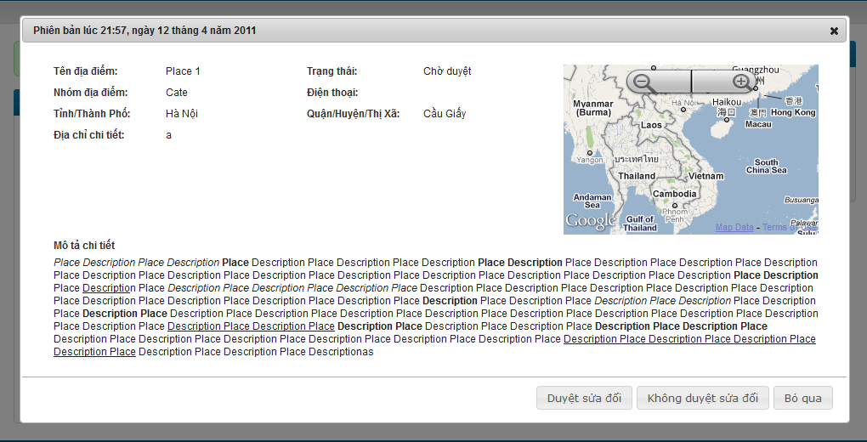

**Data Fields Definition – Attach Place Page**

|  |  |  |  |  |  |  |
| --- | --- | --- | --- | --- | --- | --- |
| **Field name** | **Description** | **Read**  **Only** | **Mandatory** | **Control Type** | **Data Type** | **Length** |
| **Basic information** | **The following fields will be surrounded by a border to allow logical grouping of data for the user. The border will have a heading titled “Phiên bản” + created date in vietnamese** | **N/A** | **N/A** | **Group Box** | **Text** | **Fixed** |
| Place name label | A label with content “Tên địa điểm” | N/A | N/A | Label | Text | Fixed |
| Place name | Place name | N/A | N/A | Label | Text | Fixed |
| Revision state label | A label with content “Trạng thái” | N/A | N/A | Label | Text | Fixed |
| Revision state | Revision state | N/A | N/A | Label | Text | Fixed |
| Category label | A label with content “Nhóm địa điểm” | N/A | N/A | Label | Text | Fixed |
| Category | Place’s category | N/A | N/A | Label | Text | Fixed |
| City label | A label with content “Tỉnh / Thành Phố” | N/A | N/A | Label | Text | Fixed |
| City | Place’s city/province | N/A | N/A | Label | Text | Fixed |
| District label | A label with content “Quận / Huyện/Thị xã” | N/A | N/A | Label | Text | Fixed |
| District | Place’s district/town/ward | N/A | N/A | label | Text | Fixed |
| Phone number label | A label with content “Điện thoại” | N/A | N/A | Label | Text | Fixed |
| Phone number | Place’s phone number | N/A | N/A | Label | Text | Fixed |
| Detail address label | A label with content “Địa chỉ chi tiết” | N/A | N/A | Label | Text | Fixed |
| Detail address | Place’s detail address | N/A | N/A | Label | Text | Fixed |
| **Mini map** | **A mini map display place location** | N/A | N/A | **Google Map API** |  |  |
| **Detail description** | **The following fields will be surrounded by a border to allow logical grouping of data for the user. The border will have a heading titled “Mô tả chi tiết”** | **N/A** | **N/A** | **Group Box** | **Text** | Fixed |
| Description box | Place’s description | N/A | N/A | Label | Text | Fixed |

**Buttons / Hyper Links – Attach Place Page**

|  |  |  |  |  |
| --- | --- | --- | --- | --- |
| **Function** | **Description** | **Available Criteria** | **Validations** | **Outcome** |
| Approve a revision | This button is used for approve a revision | Only available when revision state is unapproved | No | Revision state is updated, popup close |
| Disapprove a revision | This button is used for disapprove a revision | Only available when revision state is unapproved | No | Revision state is updated, popup close |
| cancel | The button will allow the user to close this popup | Always available | No | Popup closes |

### <Admin>View Exchange Rates

#### Use Case Diagram



#### Use Case Specification

|  |  |  |  |  |
| --- | --- | --- | --- | --- |
| **USE CASE- Set a revision is current SPECIFICATION** | | | | |
| **Use-case No.** | UC008 | **Use-case Version** | | 1.0 |
| **Use-case Name** | Set a revision as current | | | |
| **Author** | HoaHM | | | |
| **Date** | 13/04/2012 | **Priority** | Normal | |
| **Actor:**  Senior user (with more than 1000 Contribution Point) or Administrations  **Summary:**  When the quality for current revision is worse than older revision or the place information is changed back, we can go back and set an older revision as current.  **Goal:**  Set a revision as current  **Triggers**  Click to “Đặt làm phiên bản hiện tại” button at Revision Detail popup  **Preconditions:**  Logged into the system successful and open a revision’s details popup.  **Post Conditions:**  Update revision state and still stay at Edit history Page  **Main Success Scenario:**   |  |  |  | | --- | --- | --- | | Step | Actor Action | System Response | | 1 | Click to “Đặt làm phiên bản hiện tại” button | Popup closes, revision state is changed to current revision |   **Alternative Scenarios:**   |  |  |  | | --- | --- | --- | | Step | Actor Action | System Response | | 1 | Click to “Bỏ qua” button | Popup closes |   **Exceptions:**  None  **Relationships:**  Log in use case, Views edit history of a place, view a revision use case.  **Business Rules:**   |  |  |  | | --- | --- | --- | |  | Business Rule | Error Message | | 1 | Rank of an user will be set based on the user’s contribution point (CP) |  | | 2 | Contribution Point (CP) is calculated as follow: **-** Starter point for every user is 10 point - Create a place: + 20 point - Your place get deleted: - 25 point |  | | 3 | For user has more than 1000 point (senior user): - Can edit a place directly - Can upload place’s image directly - Can approve suggested edit - Can approve suggested images  - Set a revision as current |  | | 4 | For user has less than 1000 point (junior user): - an revision of a place created by these users need approvals from senior users or admins to be displayed | “Bạn chưa đủ điểm để sử dụng chức năng này” | | | | | |

**Screen**

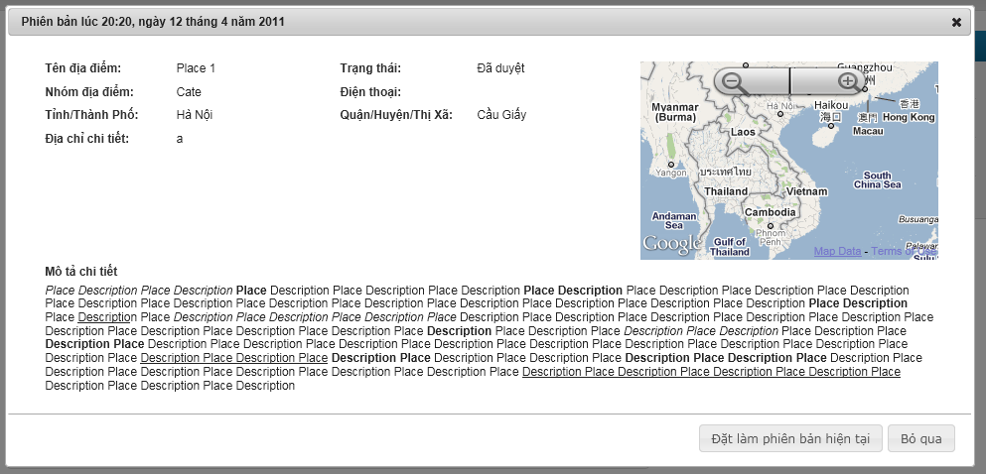

**Data Fields Definition**

|  |  |  |  |  |  |  |
| --- | --- | --- | --- | --- | --- | --- |
| **Field name** | **Description** | **Read**  **Only** | **Mandatory** | **Control Type** | **Data Type** | **Length** |
| **Basic information** | **The following fields will be surrounded by a border to allow logical grouping of data for the user. The border will have a heading titled “Phiên bản” + created date in vietnamese** | **N/A** | **N/A** | **Group Box** | **Text** | **Fixed** |
| Place name label | A label with content “Tên địa điểm” | N/A | N/A | Label | Text | Fixed |
| Place name | Place name | N/A | N/A | Label | Text | Fixed |
| Revision state label | A label with content “Trạng thái” | N/A | N/A | Label | Text | Fixed |
| Revision state | Revision state | N/A | N/A | Label | Text | Fixed |
| Category label | A label with content “Nhóm địa điểm” | N/A | N/A | Label | Text | Fixed |
| Category | Place’s category | N/A | N/A | Label | Text | Fixed |
| City label | A label with content “Tỉnh / Thành Phố” | N/A | N/A | Label | Text | Fixed |
| City | Place’s city/province | N/A | N/A | Label | Text | Fixed |
| District label | A label with content “Quận / Huyện/Thị xã” | N/A | N/A | Label | Text | Fixed |
| District | Place’s district/town/ward | N/A | N/A | label | Text | Fixed |
| Phone number label | A label with content “Điện thoại” | N/A | N/A | Label | Text | Fixed |
| Phone number | Place’s phone number | N/A | N/A | Label | Text | Fixed |
| Detail address label | A label with content “Địa chỉ chi tiết” | N/A | N/A | Label | Text | Fixed |
| Detail address | Place’s detail address | N/A | N/A | Label | Text | Fixed |
| **Mini map** | **A mini map display place location** | N/A | N/A | **Google Map API** |  |  |
| **Detail description** | **The following fields will be surrounded by a border to allow logical grouping of data for the user. The border will have a heading titled “Mô tả chi tiết”** | **N/A** | **N/A** | **Group Box** | **Text** | Fixed |
| Description box | Place’s description | N/A | N/A | Label | Text | Fixed |

**Buttons / Hyper Links**

|  |  |  |  |  |
| --- | --- | --- | --- | --- |
| **Function** | **Description** | **Available Criteria** | **Validations** | **Outcome** |
| Set a revision as current | This button is used for setting current viewing revision as current revision | Only available when revision state is approved and not current | No | Revision state is updated, popup close |
| cancel | The button will allow the user to close this popup | Always available | No | Popup closes |

### <Admin>Update Exchange Rates

#### Use Case Diagram



#### Use Case Specification

|  |  |  |  |  |
| --- | --- | --- | --- | --- |
| **USE CASE – View a place detail SPECIFICATION** | | | | |
| **Use-case No.** | UC009 | **Use-case Version** | | 1.0 |
| **Use-case Name** | View a Place Detail | | | |
| **Author** | HoaHM | | | |
| **Date** | 13/04/2012 | **Priority** | High | |
| **Actor:**  User  **Summary:**  After a user performs searching for places, the result is returned containing the most basic information of the places. If the user wants to view more information of a place, he/she can navigate to the place details page. From this page, the user can interact with the place as well as other users. The user can rate the place, comment, edit, mark as spam… All information of the place is displayed here.  The place details page may be navigated from other locations other than the search result page. For example the “top places” list. In general, the details page may be accessed from anywhere that displays the place’s identity.  **Goal:**  Display the place details to the users, and allow the users to interact with the place as well as other users.  **Triggers**  Users click a place link from anywhere in the system  **Preconditions:**  Access the website  **Post Conditions:**  The page navigates to the details page with the place’s information displayed  **Main Success Scenario:**   |  |  |  | | --- | --- | --- | | Step | Actor Action | System Response | | 1 | Searches for places by some criteria | Search result is returned | | 2 | Click a place link | The page navigates to the place details screen |   **Alternative Scenarios:**   |  |  |  | | --- | --- | --- | | Step | Actor Action | System Response | | 1 | Click to “Tạo địa điểm” tab in navigator | Rdirect to Create Place page | | 2 | Fill in required fields |  | | 3 | Click “Tạo địa điểm” button | Redirect to Place Detail page of new place |   **Exceptions:**   |  |  |  | | --- | --- | --- | | Step | Actor Action | System Response | | 1 | Click an invalid place link | Display erro page inform the user that the pge doesn’t exsit |   **Relationships:**  Search places, View edit history of a place, Edit place location on map, Report an edit of other users on a place, Report a place as fake/spam, Mark a place as visited, Share a place on other social networks, Delete a place, Place response, User comment  **Business Rules:**  None | | | | |
| **Description:**  After the user performs a search place action, he/she can choose to view details of some places from the result list. This will bring the user to the Place Details page. This page may also be navigated from anywhere that refers to its identity. After visiting this page, the user can view all information of the place.  The page will display the information of the place including:   * Place name: name of the place * Place address: full address of the place * Location on the map: the map will be shown as a medium picture and can be zoomed in/out (like Google Map). There is a point on the map indicating location of the place. The default map will show an area of 25 square kilometers (5x5) with the place spot located at the center. * Images of the place: images include a main image that displays as the place’s avatar, and other images. All images are contributed by the society, and the most liked image will become the main image. Only approved images are displayed.   The page will also show some related places to this place. They are places in the same category and have the highest popularity. The number of related places to show is 10 in maximum.  Users can perform various actions on this page, including:   * Edit the place info: refer to use case Edit a Place’s Information * Edit place location on the map: refer to use case Edit a Place’s Location * Rate the place: refer to use case Rate a Place * Comment: refer to use case Post a Comment * Mark the place as visited: refer to use case Mark a Place as Visited * Report a place as spam: refer to use case Report a Place * Upload images for the place * View a place’s revisions: refer to use case View Edit History of a Place * Add a place to your favorite list: refer to use case Add a Place to Favorite List   Increase page view  Each hit to the place details page will increase the number of page views for this place. | | | | |

**Screen**

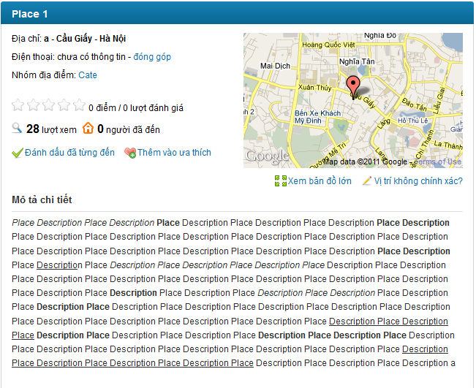

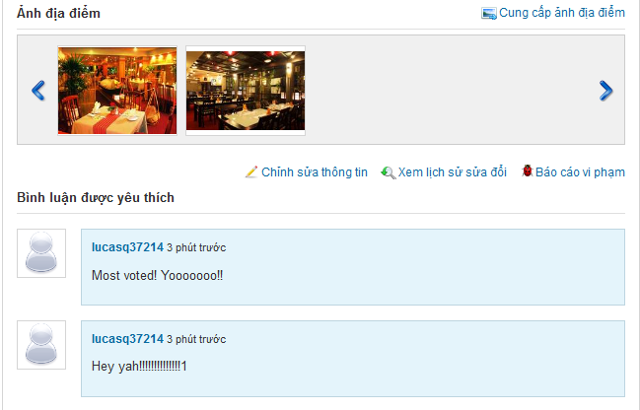

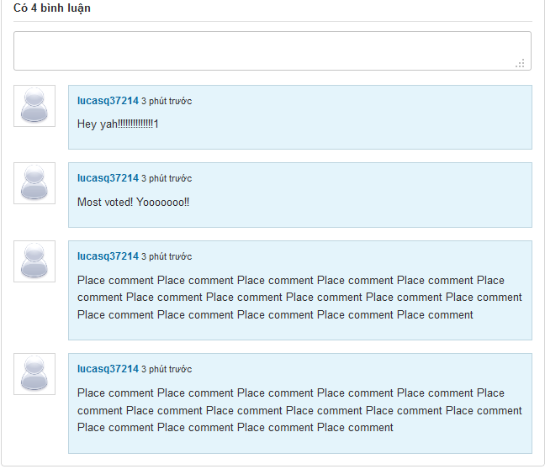

**Data Fields Definition –Create Place Page**

|  |  |  |  |  |  |  |
| --- | --- | --- | --- | --- | --- | --- |
| **Field name** | **Description** | **Read**  **Only** | **Mandatory** | **Control Type** | **Data Type** | **Length** |
| Place name | Place name is displayed at header | N/A | N/A | Label | String | Fixed |
| Detail address | A label contains detail address, created by Detail Address + District/Town/Ward + City/Province | N/A | N/A | Label | String | Fixed |
| Phone number | A label contains place’s phone number | N/A | N/A | Label | String | Fixed |
| Rating | A label with content: 5 star symbols + current rating + rate times + “ lượt đánh giá” | N/A | N/A | Label | String | Fixed |
| View number | A label with content: view number + “lượt xem” | N/A | N/A | Label | String | Fixed |
| Visited number | A label with content: visited number + “người đã đến” | N/A | N/A | Label | String | Fixed |
| description | A label contains place description | N/A | N/A | Label | String | Fixed |

**Buttons / Hyper Links – Q&A Screen**

|  |  |  |  |  |
| --- | --- | --- | --- | --- |
| **Function** | **Description** | **Available Criteria** | **Validations** | **Outcome** |
| “đóng góp” hyperlink | Allow user open Edit Place page | Only Available when unrequired fields are leave blank when creating place | No validation | Redirect user to Edit Place page |
| “Xem bản đồ lớn” hyperlink | Allow user to see place location in bigger map | Always Available | No validation | Popup a window with bigger map |
| “Vị trí không chính xác?” hyperlink | Allow user to edit place location | Always Available | No validation | Popup a window with bigger map for changing location |
| “Đánh dấu đã từng đến” hyperlink | Allow user mark current viewing place as visited | Always Available | No validation | Visited number is increased by 1, display message “Địa điểm đã được đánh dấu.  ” |
| “Thêm vào ưa thích” hyperlink | Allow user to add current viewing place to favorite list | Always Available | No validation | Display message “Địa điểm đã được thêm vào ưa thích” |
| “Cung cấp ảnh địa điểm” hyperlink | Allow user to upload images for current viewing place | Always Available | No validation | Popup window with uploader for upload images |
| “Chỉnh sửa thông tin” hyperlink | Allow user edit open Edit Place page | Always Available | No validation | Redirect user to Edit Place page |
| “Xem lịch sử sửa đổi” hyperlink | Allow user to view revisions of current viewing place | Always Available | No validation | Redirect user to Revisions page |
| “Báo cáo vi phạm” hyperlink | Allow user to report a place | Always Available | No validation | Popup report window |
| Category link | This link will search all place belong to selected category | Always Available | No validation | Redirect user to Search Place page with search results contains all places belong to selected category |
| User link | This hyperlink helps user open User Profile page | Display with each comment | No validation | Redirect user to User Profile page |

### <Admin>View active exchange settings

#### Use Case Diagram



#### Use Case Specification

|  |  |  |  |  |
| --- | --- | --- | --- | --- |
| **USE CASE – Search places SPECIFICATION** | | | | |
| **Use-case No.** | UC010 | **Use-case Version** | | 1.0 |
| **Use-case Name** | Search Places | | | |
| **Author** | HoaHM | | | |
| **Date** | 13/04/2012 | **Priority** | High | |
| **Actor:**  User  **Summary:**  This is one of the main functions of the system. Users can search for places by some criteria in order to find the best place suitable for their need. The criteria may include place category, distance, popularity… The search result will be filtered to support users find the right place as quick as possible.  The search function will include quick search and advanced search. Quick search is available to the user right from the home page and accept the most basic criteria like category and area. Advanced search will accept more criteria to help users filter search result more precisely.  **Goal:**  Search for places  **Triggers**  Users enter search criteria and click search button  **Preconditions:**  Access the website  **Post Conditions:**  The page navigates to search result screen with the result displayed  **Main Success Scenario:**   |  |  |  | | --- | --- | --- | | Step | Actor Action | System Response | | 1 | Enters place category to the search text box |  | | 2 | Clicks “Tìm kiếm” buton | Display search result |   **Alternative Scenario - Suggestion:**   |  |  |  | | --- | --- | --- | | Step | Actor Action | System Response | | 1 | Enters place category to the search text box | The system displays suggestions which have similar spellings with the text entered | | 2 | Chooses one of the suggestions |  | | 3 | Clicks “Tìm kiếm” button | Display search result |   **Alternative Scenario – Advanced Search**   |  |  |  | | --- | --- | --- | | Step | Actor Action | System Response | | 1 | Clicks “Tìm kiếm nâng cao” hyperlink | New region on the page is displayed with more search criteria inputs | | 2 | Enters search criteria |  | | 3 | Clicks “Tìm kiếm” button | Display search result |   **Alternative Scenario – No result**   |  |  |  | | --- | --- | --- | | Step | Actor Action | System Response | | 1 | Enter category which has no place belong to |  | | 2 | Clicks “Tìm kiếm” button | Display “Không tìm thấy địa điểm nào!” |   **Exceptions:**  N/A  **Relationships:**  None  **Business Rules:**  None | | | | |
| **Description:**  Users will use this function to search for places that best fit for their need. The user will input some search criteria and the system will return the result based on those criteria.  Quick Search  This is one of main regions on the system. Use can access to it right at the home page or go to Search Place page by click to “Tìm kiếm” at navigator. The region contains 2 fields: “Tìm gì, mua gì” and “Ở đâu”. With the first field, the users will enter place’s category or place name they want to search. For example: “cà phê”, “rửa xe”, “Ngân hàng ACB”… With the second field, the users will enter the area they want to find places in. The areas are specified as a city/province/district/town/ward... For example: “Hà Nội”, “Cầu Giấy, Hà Nội”…  A place is included in the search result if it matches all the search criteria. For example, if a user enters “Cà phê” as the category, and “Cầu Giấy, Hà Nội” as the area, only coffee shops in Cau Giay, Ha Noi are included in the search result.  The search area field will be auto populated by data from the user’s browser cookies if already existed. Otherwise, it will be based on the user’s IP address. That is if the user first visits the website, the search area text box will be populated based on the user’s IP. After the user performs the search function, the content of that text box will be stored in the user’s browser cookies and will be the retrieved to populate that text box the next time user performs searching.  Advanced Search  This function will provide users more options to tailor search result more precisely. The options include:   * Search category and search area: like quick search * Distance to the user’s location. The distance will be specified in Kilometers. In order to use this feature, the user must specify his location on the map. The location will be retrieved from the user info if he has logged in, or from the user’s browser cookies if existed there. If none of the two sources exists, the user will be prompted to select his location on the map. After the user specifies his location, the location is saved to the user info (if logged in) and the user’s browser cookies. Search result will only include places distance from which is not longer than the Km specified. * Rating must be greater than or equal to. Users can restrict this field to filter places with best rating.   Search Suggestions  After the user enters first characters into the search text boxes, the system will display some suggestions below the text boxes that have the similar spelling. Here are some considerations that take into account when display the suggestions:   * The suggestions are not case-sensitive. That is it doesn’t matter that the user enters upper or lower case characters into the text boxes, the suggestions must be the same. * The suggestions are not Unicode-sensitive. That is if the user enters “ca phe”, the suggestions will be the same as if the user enters “cà phê”. * An item will be included in the suggestions if it contains the character sequence entered in the text box, ignoring the spaces. Item containing the sequence at index i will be displayed before item containing the sequence at index j if i < j. If i = j, the items will be ordered based on the number of searches performed on that item.   For example: if the user input “Cà” in the search category, the system will suggest: “Cà phê”, “Cà chua”, “Cà pháo”, “Giáp lá cà”, if the term “Cà phê” is searched the most in the triplet. If the user inputs “Cà p”, only “Cà phê” and “Cà pháo” are displayed in the suggestions.   * A category is associated with many aliases. For example “Cà phê” may also be called “café”. The suggestions must be checked with those aliases as well. * Area text box will suggest only city/province/district/town/ward. For example: “Hà Nội”, “Cầu Giấy, Hà Nội”.   Search Result  Search result must match all the criteria inputted. Each place appearing in the search result will display the following information: Place name, place image, rating, number of raters, number of comments, number of page views.  Users will have the options to sort places by rating, number of comments and number of page views. Default will be “rating descending”.  Search result will be paged with 20 items per page. User only need click to “Xem thêm” at the end of result list to see more search result. | | | | |

**Screen**

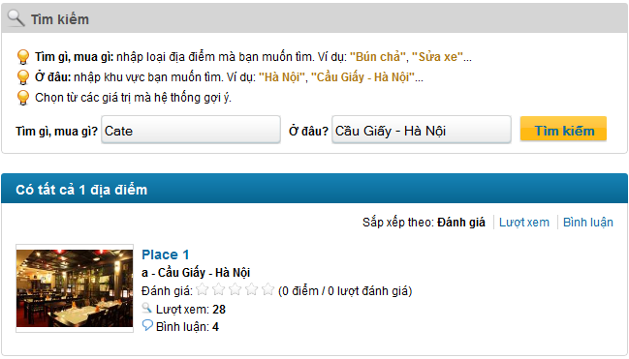

**Data Fields Definition – Search Places**

|  |  |  |  |  |  |  |
| --- | --- | --- | --- | --- | --- | --- |
| **Field name** | **Description** | **Read**  **Only** | **Mandatory** | **Control Type** | **Data Type** | **Length** |
| **Search Area** | | | | | | |
| Instruction | Contains instructions for searching place | Y | Y | Label | String | Fixed |
| Category Seach label | A label with content “Tìm gì, mua gì?” | Y | Y | Label | String | Fixed |
| Category search | Category used for searched | N | Y | Text box | String | 100 |
| Address part search label | A label with content “Ở đâu?” | Y | Y | Label | String | Fixed |
| Address part seach | Address part used for searched | N | Y | Text box | String | 100 |
| **Sort Area** | | | | | | |
| Sort label | A label with content “Sắp xếp theo” | Y | Y | Label | String | Fixed |
| Rating label | A label with content “Đánh giá” | Y | Y | Label | String | Fixed |
| View label | A label with content “Lượt xem” | Y | Y | Label | String | Fixed |
| Comment label | A label with content “Bình luận” | Y | Y | Label | String | Fixed |
| **Result Area – each place contains:** | | | | | | |
| Place name | A label contains place name | Y | Y | Label | String | Fixed |
| Detail address | A label contains place detail address + district/town/ward + city/province | Y | Y | Label | String | Fixed |
| Rating | A label contains place rating | Y | Y | Label | String | Fixed |
| View number | A label contains place view number | Y | Y | Label | String | Fixed |
| Comment number | A label contains place comment number | Y | Y | Label | String | Fixed |

**Buttons / Hyper Links – Search Places**

|  |  |  |  |  |
| --- | --- | --- | --- | --- |
| **Function** | **Description** | **Available Criteria** | **Validations** | **Outcome** |
| Search place | A button which start searching for places based on inputted criteria | Always available | Category isn’t blank | Display results below search area or message “Không tìm thấy địa điểm nào!” |
| Sort by rating | A link that sort search results based on place’s rating, from highest to lowest | Available when dispay search results |  | All results are sorted by rating, from highest to lowest |
| Sort by view number | A link that sort search results based on place’s view number, from highest to lowest | Available when dispay search results |  | All results are sorted by view number, from highest to lowest |
| Sort by comment number | A link that sort search results based on place’s comment number, from highest to lowest | Available when dispay search results |  | All results are sorted by comment number, from highest to lowest |
| Place link | This link will navigate user to Place Detail page | Available when dispay search results |  | Redirect to Place Detail page |

### <Admin>View all exchange settings

#### Use Case Diagram



#### Use Case Specification

|  |  |  |  |  |
| --- | --- | --- | --- | --- |
| **USE CASE- Report a place SPECIFICATION** | | | | |
| **Use-case No.** | UC011 | **Use-case Version** | | 1.0 |
| **Use-case Name** | Report a place | | | |
| **Author** | HoaHM | | | |
| **Date** | 13/04/2012 | **Priority** | Normal | |
| **Actor:**  User  **Summary:**  When user detect a place is fake, doesn’t exist or created by untrusted user or contains inappropriate content, he/she can report that place to the administrator and let administrator team handle it.  **Goal:**  This use case allows the actor report a place as fake/spam/inappropriate.  **Triggers**  Click to “Báo cáo vi phạm” hyperlink in the place’s details page.  **Preconditions:**  Successfully logged into the system and open place’s details page.  **Post Conditions:**  Stay remains at Place Detail page  **Main Success Scenario:**   |  |  |  | | --- | --- | --- | | Step | Actor Action | System Response | | 1 | Click to “Báo cáo vi phạm” hyperlink | System shows a popup to confirm and user can add more reason why this lace is reported. | | 2 | Click to “Báo cáo” button. | Display popup notify success message “Báo cáo vi phạm hoàn tất! Ban quan trị sẽ kiểm tra lại trong thời gian sớm nhất.” | | 3 | Click to OK button | Popups close |   **Alternative Scenarios:**   |  |  |  | | --- | --- | --- | | Step | Actor Action | System Reponse | | 1 | Click to “Báo cáo vi phạm” hyperlink | System shows a popup to confirm and user can add more reason why this place is reported. | | 2 | Enter reason |  | | 3 | Click to “Báo cáo” button. | Display popup notify success message “Báo cáo vi phạm hoàn tất! Ban quan trị sẽ kiểm tra lại trong thời gian sớm nhất.” | | 4 | Click to OK button | Popups close |  |  |  |  | | --- | --- | --- | | Step | Actor Action | System Response | | 1 | Click to “Báo cáo vi phạm” hyperlink | System shows a popup to confirm and user can add more reason why this place is reported. | | 2 | Enter reason |  | | 3 | Click to “Bỏ qua” button. | Popup close |   **Exceptions:**   |  |  |  | | --- | --- | --- | | Step | Actor Action | System Response | | 1 | Click to “Báo cáo vi phạm” hyperlink | System shows a popup to confirm and user can add more reason why this place is reported. | | 2 | Enter reason |  | | 3 | Click to “Báo cáo” button. | Display popup notify success message “Báo cáo vi phạm hoàn tất! Ban quan trị sẽ kiểm tra lại trong thời gian sớm nhất.” | | 4 | Click to OK button | Popups close | | 5 | Click to “Báo cáo vi phạm” hyperlink | Display popup message “Báo cáo vi phạm hoàn tất! Ban quan trị sẽ kiểm tra lại trong thời gian sớm nhất.” |   **Relationships:**  Log in use case, View a place’s details use case.  **Business Rules:**   |  |  |  | | --- | --- | --- | |  | Business Rule | Error Message | | 1 | 1 place can only be reported by 1 user once |  | | | | | |

**Screen**

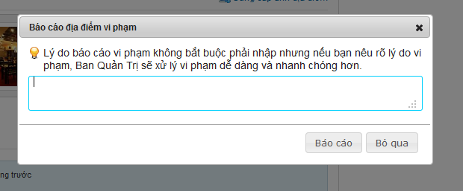

**Data Fields Definition – Comment Area**

|  |  |  |  |  |  |  |
| --- | --- | --- | --- | --- | --- | --- |
| **Field name** | **Description** | **Read**  **Only** | **Mandatory** | **Control Type** | **Data Type** | **Length** |
| instruction | Contains instructions for reporting a place | Y | Y | Label | String | Fixed |

**Buttons / Hyper Links – Comment Area**

|  |  |  |  |  |
| --- | --- | --- | --- | --- |
| **Function** | **Description** | **Available Criteria** | **Validations** | **Outcome** |
| Send a report | This button will send a report to server | Always available | No validation | Display popup notify success message “Báo cáo vi phạm hoàn tất! Ban quan trị sẽ kiểm tra lại trong thời gian sớm nhất.” |
| Cancel | This button will close popup | Always available | No validation | Close popup |

### <Admin>Add new currency

#### Use Case Diagram



#### Use Case Specification

|  |  |  |  |  |
| --- | --- | --- | --- | --- |
| **USE CASE- Mark a place as visited SPECIFICATION** | | | | |
| **Use-case No.** | UC012 | **Use-case Version** | | 1.0 |
| **Use-case Name** | Mark a place as visited | | | |
| **Author** | HoaHM | | | |
| **Date** | 13/04/2012 | **Priority** | Normal | |
| **Actor:**  User  **Summary:**  When visiting a place, user realize that he/she visited this place it is an interesting place. So it’s very convenient if he/she can click to “Đánh dấu đã từng đến” hyperlink and make this place more reliable.  **Goal:**  This use case allows the actor mark a place as visited.  **Triggers**  Click to “Đánh dấu đã từng đến” hyperlink in the place’s details page.  **Preconditions:**  Successfully logged into the system  **Post Conditions:**  Visited number is increased by 1, stay remain at Place Detail page  **Main Success Scenario:**   |  |  |  | | --- | --- | --- | | Step | Actor Action | System Response | | 1 | Click to “Đánh dấu đã từng đến” hyperlink. | Visited number is increased by 1 and a message is displayed “Địa điểm đã được đánh dấu.” |   **Exceptions:**   |  |  |  | | --- | --- | --- | | Step | Actor Action | System Response | | 1 | Click to “Đánh dấu đã từng đến” hyperlink. | Visited number is increased by 1 and a message is displayed “Địa điểm đã được đánh dấu.” | | 2 | Click to “Đánh dấu đã từng đến” hyperlink. | a message is displayed “Địa điểm đã được đánh dấu.” |   **Relationships:**  Log in use case, View a place’s details use case.  **Business Rules:**   |  |  |  | | --- | --- | --- | |  | Business Rule | Error Mssage | | 1 | Each user has only 1 time to mark a place as visited. |  | | | | | |

**Screen**

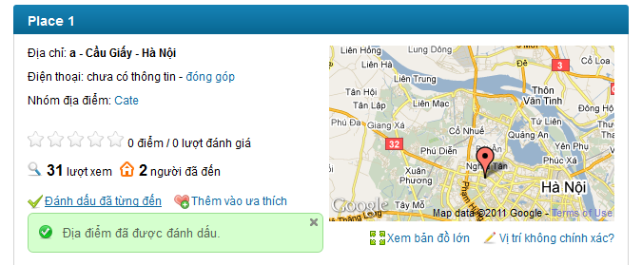

### <Admin>Update currencies

#### Use Case Diagram



#### Use Case Specification

|  |  |  |  |  |
| --- | --- | --- | --- | --- |
| **USE CASE – Rate a place SPECIFICATION** | | | | |
| **Use-case No.** | UC013 | **Use-case Version** | | 1.0 |
| **Use-case Name** | Rate a place | | | |
| **Author** | HoaHM | | | |
| **Date** | 13/04/2012 | **Priority** | High | |
| **Actor:**  User  **Summary:**  When the user views information of a place, he/she can rate that place based on the usefulness of the information or his/her opinion about that place. The user only need move the mouse to the rating bar, choose rating and click. The user rating will be used to calculate the total rating of the place. User can change the rating by rate it again. The last rating time of the user will be used to calculate. The rating is from 1 to 5 stars.  **Goal:**  Rate a place from 1 to 5 stars  **Triggers**  Click to rating bar  **Preconditions:**  Successfully logged into the system and open a place detail page  **Post Conditions:**  Stay remains at current place page with a rating saved.  **Main Success Scenario:**   |  |  |  | | --- | --- | --- | | Step | Actor Action | System Response | | 1 | Click to rating bar at the decided rating | Rating is saved and displayed by number of star turn from white to orange. A message is displaed “Cảm ơn bạn đã đánh giá địa điểm này.” |   **Alternative Scenario:**   |  |  |  | | --- | --- | --- | | Step | Actor Action | System Response | | 1 | Click to rating bar at the decided rating | Rating is saved and displayed by number of star turn from white to orange. A message is displaed “Cảm ơn bạn đã đánh giá địa điểm này.” | | 2 | Click to rating bar again at new decided rating | Save the new user rating. A message is displaed “Cảm ơn bạn đã đánh giá địa điểm này.” |   **Exceptions: -**  **Relationships:**  Log in use case  **Business Rules:**   |  |  |  | | --- | --- | --- | | **No** | **Rule Description** | **Error Message** | | 1 | The rating of 1 place is average of all user rates |  | | 2 | The rating is from 1 to 5 stars. |  | | 3 | The user can only rate 1 place many times. The last rating will be count as the user’s rate |  | | | | | |
| **Description:**  When the user views information of a place, he/she can rate that place based on the usefulness of the information or his/her opinion about that place.The user only need move the mouse to the rating bar, choose rating and click. The user rating will be used to calculate the total rating of the place. User can change the rating by rate it again. The last rating time of the user will be used to calculate. The rating is from 1 to 5 stars. The rating bar has 5 white star symbols. The saved rating will be display in orange. Beside rating bar there is user rating displayed in text with number or rate times of current viewing place.  The rating will be used for ranking all places in the system and displayed hottest place as a list at homepage. It also will be used to sorted places in search result list. The rating used for sort isn’t averate rating of a place, but total rating. We used this method for sorting because we don’t want to let a 5 stars place with only 1 vote time be put above 4stars place with 1000 vote times. So this way will be much fairer in our opinion. | | | | |

**Screen**

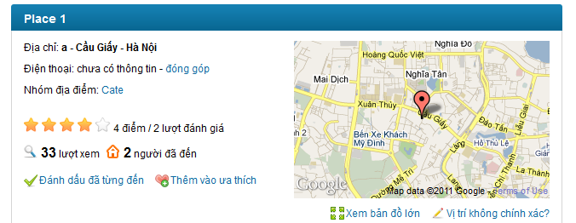

### <Admin>View all member

#### Use Case Diagram



#### Use Case Specification

|  |  |  |  |  |
| --- | --- | --- | --- | --- |
| **USE CASE – Post a comment SPECIFICATION** | | | | |
| **Use-case No.** | UC014 | **Use-case Version** | | 1.0 |
| **Use-case Name** | Post A Comment | | | |
| **Author** | HoaHM | | | |
| **Date** | 13/04/2012 | **Priority** | High | |
| **Actor:**  User  **Summary:**  When the user wants to express his/her opinion about how they feel about the place, the user can do it by post a comment. The user can enter whatever he/she would like to in comment box and click to “**Bình luận**” button to post it on a place detail page.    **Goal:**  Post a comment on a place page  **Triggers**  Click to comment textbox  **Preconditions:**  Successfully logged into the system and open a place detail page  **Post Conditions:**  Stay remain at current place page with a comment was added and displayed on top of comment area.  **Main Success Scenario:**   |  |  |  | | --- | --- | --- | | Step | Actor Action | System Response | | 1 | Click to comment text box | “Bình luận” and “Bỏ qua” button are visible | | 2 | Enter the content | - | | 3 | Click “**Bình luận”** button | Add user’s comment to comment area. User’s comment was put on top so that the user can see right away that his/her comment was posted |   **Alternative Scenario:**   |  |  |  | | --- | --- | --- | | Sep | Actor Action | System Response | | 1 | Click to comment text box | “Bình luận” and “Bỏ qua” button are visible | | 2 | Enter the content | - | | 3 | Click “**Bỏ qua”** button | Clear comment box, 2 buttons are hidden |   **Exceptions:**   |  |  |  | | --- | --- | --- | | Step | Actor Action | System Response | | 1 | Click to comment text box | “Bình luận” and “Bỏ qua” button are visible | | 2 | Click “**Bình luận”** button | Nothing happen |   **Relationships:**  Log in use case  **Business Rules:**   |  |  |  | | --- | --- | --- | | **No** | **Rule Description** | **Error Message** | | 1 | A comment with blank content won’t be posted |  | | | | | |
| **Description:**  When user want to express his/her opinion about how they feel about the place, the user can do it by enter whatever he/she would like to in comment box and click to “Bình luận” button to post it on a place page. The comment cannot be blank and must be less then 4000 characters because the maximum length that can be inserted into database is 4000. The “Bình luận” and “Bỏ qua” buttons will be showed only after the user click to the comment box. The user can easily cancel posting a question by click to “Bỏ qua” button. After successfully posting a comment, the comment will be displayed on top of comment area.  Comment area is an area which displayed comments posted by users. The latest comment will be put on top. By default, only 10 latest comments are displayed at Place Detail page, user need click to “Xem thêm” at the end of comment area to see more comments. | | | | |

**Screen**

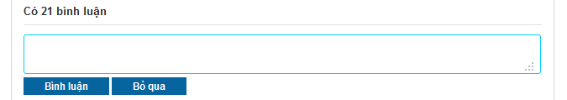

**Buttons / Hyper Links – Comment Area**

|  |  |  |  |  |
| --- | --- | --- | --- | --- |
| **Function** | **Description** | **Available Criteria** | **Validations** | **Outcome** |
| Post a comment | This button will post a comment to place detail page | It will be showed when user click to Comment box | Comment shouldn’t be blank | Post validated comment to place detail page, put it on top of Comment area |
| Cancel | This button will clear the content of the comment | It will be showed when user click to comment box | No validation | Comment box was cleared and 2 buttons are hidden |

### <Admin>Filter member

#### Use Case Diagram



#### Use Case Specification

|  |  |  |  |  |
| --- | --- | --- | --- | --- |
| **USE CASE – Delete a comment SPECIFICATION** | | | | |
| **Use-case No.** | UC015 | **Use-case Version** | | 1.0 |
| **Use-case Name** | Delete a comment | | | |
| **Author** | HoaHM | | | |
| **Date** | 13/04/2012 | **Priority** | High | |
| **Actor:**  User  **Summary:**  When the user post a double comment or post something that he/she regrets later, the user can delete it from comment area so no one can see what he/she just posted or avoid get reported as spam. He/ she can move the mouse to his/her comment then click to a button with X symbol just appear to delete the comment.  **Goal:**  Delete your comment from comment area.  **Triggers**  Move the mouse to your comment and click to a button with X symbol  **Preconditions:**  Successfully logged into the system and open a place detail page  **Post Conditions:**  Stay remain at current place page with a comment was deleted from comment area.  **Main Success Scenario:**   |  |  |  | | --- | --- | --- | | Step | Actor Action | System Response | | 1 | Move the mouse to your comment | A button with X symbol appear | | 2 | Click to X button | The comment disappear from comment area |   **Alternative Scenario:**  None  **Exceptions: -**  **Relationships:**  Log in use case  **Business Rules:**   |  |  |  | | --- | --- | --- | | **No** | **Rule Description** | **Error Message** | | 1 | You can only delete your own comment |  | | | | | |

**Screen**

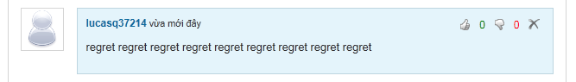

**Buttons / Hyper Links**

|  |  |  |  |  |
| --- | --- | --- | --- | --- |
| **Function** | **Description** | **Available Criteria** | **Validations** | **Outcome** |
| Delete a comment | This button is displayed with a X symbol and it is used to delete the comment from comment area | It will be showed when user move the mouse pointer to his/her comment | No validation | The comment is deleted from comment area |
| Vote up | This button is displayed with thumb up symbol and it is used to vote up for a comment | It will be showed when user move the mouse pointer to a comment | No validation | Vote up number is increased by 1, thumb up symbol turn into green |
| Vote down | This button is displayed with thumb down symbol and it is used to vote down for a comment | It will be showed when user move the mouse pointer to a comment | No validation | Vote down number is increased by 1, thumb down symbol turn into red |

### <Admin>Search member

#### Use Case Diagram



#### Use Case Specification

|  |  |  |  |  |
| --- | --- | --- | --- | --- |
| **USE CASE – Vote a comment SPECIFICATION** | | | | |
| **Use-case No.** | UC016 | **Use-case Version** | | 1.0 |
| **Use-case Name** | Vote a comment | | | |
| **Author** | HoaHM | | | |
| **Date** | 13/04/2012 | **Priority** | Normal | |
| **Actor:**  User  **Summary:**  When the user see a good/bad comment, they want to do something to show that they like it or hate it. The user can do that. They can vote a comment by move the mouse to desired comment and click to button with thumb up symbol if they like it or button with thumb down symbol if they hate it.  **Goal:**  Vote up for comment you like or vote down for comment you hate.  **Triggers**  Move the mouse to a comment and click to button with thumb up symbol or button with thumb down symbol  **Preconditions:**  Successfully logged into the system and open a place detail page  **Post Conditions:**  Stay remain at current place page with a comment was voted.  **Main Success Scenario:**   |  |  |  | | --- | --- | --- | | Step | Actor Action | System Response | | 1 | Move the mouse to the comment needed to be voted | Button with thumb up symbol and button with thumb down symbol appear | | 2 | Click to thumb up button | Change the color of thumb up button (from white color to green color), vote up number is increased by 1 |   **Alternative Scenario:**   |  |  |  | | --- | --- | --- | | Step | Actor Action | System Response | | 1 | Move the mouse to the comment needed to be voted | Button with thumb up symbol and button with thumb down symbol appear | | 2 | Click to thumb down button | Change the color of thumb down button (from white color to red color), vote down comment is increased by 1 |  |  |  |  | | --- | --- | --- | | Step | Actor Action | System Response | | 1 | Move the mouse to the comment needed to be voted | Button with thumb up symbol and button with thumb down symbol appear | | 2 | Click to thumb up button | Change the color of thumb up button (from white color to green color), vote up number is increased by 1 | | 3 | Click to thumb up button again | Nothing happen |  |  |  |  | | --- | --- | --- | | Step | Actor Action | System Response | | 1 | Move the mouse to the comment needed to be voted | Button with thumb up symbol and button with thumb down symbol appear | | 2 | Click to thumb down button | Change the color of thumb down button (from white color to red color), vote down comment is increased by 1 | | 3 | Click to thumb down button again | Nothing happen |  |  |  |  | | --- | --- | --- | | Step | Actor Action | System Response | | 1 | Move the mouse to the comment needed to be voted | Button with thumb up symbol and button with thumb down symbol appear | | 2 | Click to thumb up button | Change the color of thumb up button (from white color to green color), vote up number is increased by 1 | | 3 | Click to thumb down button | Thumb up symbol turn back into white, thumb down symbol turn into red, vote up number is decreased by 1, vote down number is increased by 1 |  |  |  |  | | --- | --- | --- | | Step | Actor Action | System Response | | 1 | Move the mouse to the comment needed to be voted | Button with thumb up symbol and button with thumb down symbol appear | | 2 | Click to thumb down button | Change the color of thumb down button (from white color to red color), vote down comment is increased by 1 | | 3 | Click to thumb up button | Thumb down symbol turn back into white, thumb up symbol turn into green, vote down number is decreased by 1, vote up number is increased by 1 |   **Exceptions:**  **Relationships:**  Log in use case  **Business Rules:**   |  |  |  | | --- | --- | --- | | **No** | **Rule Description** | **Error Message** | | 1 | Each account can only vote up or vote down and only increased vote number by 1 per comment |  | | | | | |
| **Description:**  When the user see a good/bad comment, they want to do something to show that they like it or hate it. The user can do that. They can vote a comment by move the mouse to a comment and click to thumb up icon if they like it or thumb down icon if they hate it. The vote will be record and the 2 most voted up comments will be highlighted and put on top of comment area. The last vote count means that the user can change to vote up to vote down or change back to vote up and the system will using your last vote as your vote. The vote up is displayed as thumb up icon. The vote down is displayed as thumb down icon. Both icons in white at start. When the icon is clicked, its color will change (green in case of vote up and red in case of vote down). If the user clicks to 1 icon, then clicks other icon too. The last clicked icon will be in blue/red color, the other will be in white. 2 highlighted comments still can be voted like normal comment. Highlight Comment Area is above Comment Area. Each user can only vote for other user’s comments. You can’t vote for your own comment. When you click to thumb up or thumb down icon at your comment, nothing will happen. | | | | |

**Screen**

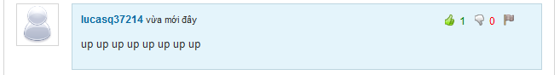

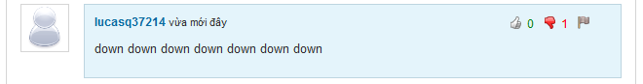

**Buttons / Hyper Links**

|  |  |  |  |  |
| --- | --- | --- | --- | --- |
| **Function** | **Description** | **Available Criteria** | **Validations** | **Outcome** |
| Delete a comment | This button is displayed with a X symbol and it is used to delete the comment from comment area | It will be showed when user move the mouse pointer to his/her comment | No validation | The comment is deleted from comment area |
| Vote up | This button is displayed with thumb up symbol and it is used to vote up for a comment | It will be showed when user move the mouse pointer to a comment | No validation | Vote up number is increased by 1, thumb up symbol turn into green |
| Vote down | This button is displayed with thumb down symbol and it is used to vote down for a comment | It will be showed when user move the mouse pointer to a comment | No validation | Vote down number is increased by 1, thumb down symbol turn into red |

### <Admin>View detail member

#### Use Case Diagram



#### Use Case Specification

|  |  |  |  |  |
| --- | --- | --- | --- | --- |
| **USE CASE – Highlight best comment SPECIFICATION** | | | | |
| **Use-case No.** | UC017 | **Use-case Version** | | 1.0 |
| **Use-case Name** | Highlight Best Comment | | | |
| **Author** | HoaHM | | | |
| **Date** | 13/04/2012 | **Priority** | Normal | |
| **Actor:**  User  **Summary:**  Each time the user vote for a comment, the vote will be counted. 2 comments which have most votes up and will be highlighted and put up on top of comment box. The user can see them and vote for them as normal comment. The highlight comment area will be displayed as the user open a place detail page.  **Goal:**  Show 2 most vote up comments  **Triggers**  Open a place detail page  **Preconditions:**  Access the website  **Post Conditions:**  Stay remains at place detail page  **Main Success Scenario:**   |  |  |  | | --- | --- | --- | | Step | Actor Action | System Response | | 1 | Open an place detail place | Display 2 most vote up comments on top of comment box |   **Alternative Scenario:**  **Exceptions:**   |  |  |  | | --- | --- | --- | | Step | Actor Action | System Response | | 1 | Open an place detail place which has no comment has vote up | The highlight comment area is hidden |  |  |  |  | | --- | --- | --- | | Step | Actor Action | System Response | | 1 | Open an place detail place which has only 1 comment has vote up | Display only 1 most vote up comments on top of comment box |   **Relationships:**  Log in use case  **Business Rules:**   |  |  |  | | --- | --- | --- | | **No** | **Rule Description** | **Error Message** | | 1 | Only 2 most vote up comment will be highlighted and put up on highlight comment area |  | | 2 | Highlighted comments can be treated as normal comment |  | | | | | |
| **Description:**  Based on vote system, we select 2 most voted up comments, highlight it and put it at different area. These 2 comments still acted as normal comment. The thing is these comment will get more attention from other users because they are put on Highlight Comment Area on top of Comment Area. When there isn’t any comment get vote up, Highlight Comment Area will be hidden. If there is only 1comment get voted up, the Highlight Comment Area will display this only comment. | | | | |

**Screen**

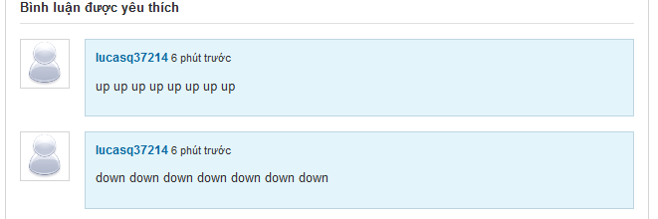

### <Admin>Update member

#### Use Case Diagram



#### Use Case Specification

|  |  |  |  |  |
| --- | --- | --- | --- | --- |
| **USE CASE – Report a comment SPECIFICATION** | | | | |
| **Use-case No.** | UC018 | **Use-case Version** | | 1.0 |
| **Use-case Name** | Report a comment | | | |
| **Author** | HoaHM | | | |
| **Date** | 13/04/2012 | **Priority** | High | |
| **Actor:**  User  **Summary:**  When the user sees someone is spamming by posting many comment with nonsense, unrelated inappropriate or advertising content, they can report it. The user must move the mouse to spam comment and click to button with flag symbol. The comment will be deleted manually by admins when they review the comment.  **Goal:**  Report a comment as spam or inappropriate.  **Triggers**  Move the mouse to a comment and click to button with flag symbol  **Preconditions:**  Successfully logged into the system and open a place detail page  **Post Conditions:**  Stay remain at current place page with a comment was reported.  **Main Success Scenario:**   |  |  |  | | --- | --- | --- | | Step | Actor Action | System Response | | 1 | Move the mouse to the comment needed to be reported | A button with flag symbol appears | | 2 | Click to flag button | Popup a window | | 3 | Click to “Báo cáo” button | Popup a message “Báo cáo vi phạm hoà tất! Ban quan trị sẽ kiểm tra lại trong thời gian sớm nhất.” | | 4 | Click OK | Popups close |   **Alternative Scenario:**   |  |  |  | | --- | --- | --- | | Step | Actor Action | System Response | | 1 | Move the mouse to the comment needed to be reported | A button with flag symbol appears | | 2 | Click to flag button | Popup a window | | 3 | Enter reason |  | | 4 | Click to “Báo cáo” button | Popup a message “Báo cáo vi phạm hoàn tất! Ban quan trị sẽ kiểm tra lại trong thời gian sớm nhất.” | | 5 | Click OK | Popups close |  |  |  |  | | --- | --- | --- | | Step | Actor Action | System Response | | 1 | Move the mouse to the comment needed to be reported | A button with flag symbol appears | | 2 | Click to flag button | Popup a window | | 3 | Enter reason with more than 100 characters |  | | 4 | Click to “Báo cáo” button | Popup a message “Lý do không dài quá 100 ký tự.” | | 5 | Click OK | Wanring popup closes, report popup still opens |  |  |  |  | | --- | --- | --- | | Step | Actor Action | System Response | | 1 | Move the mouse to the comment needed to be reported | A button with flag symbol appears | | 2 | Click to flag button | Popup a window | | 3 | Enter reason |  | | 4 | Click to “Bỏ qua” button | Popup closes |  |  |  |  | | --- | --- | --- | | Step | Actor Action | System Response | | 1 | Move the mouse to the comment needed to be reported | A button with flag symbol appears | | 2 | Click to flag button | Popup a window | | 3 | Enter reason |  | | 4 | Click to “Báo cáo” button | Popup a message “Báo cáo vi phạm hoàn tất! Ban quan trị sẽ kiểm tra lại trong thời gian sớm nhất.” | | 5 | Click OK | Popups close | | 6 | Click to flag button again | Popup a message “Báo cáo vi phạm hoàn tất! Ban quan trị sẽ kiểm tra lại trong thời gian sớm nhất.” |   **Exceptions: -**  **Relationships:**  Log in use case  **Business Rules:**   |  |  |  | | --- | --- | --- | | **No** | **Rule Description** | **Error Message** | | 1 | Each user can only report 1 comment once |  | | | | | |
| **Description:**  When the user sees someone is spamming by posting many comment with nonsense, unrelated inappropriate or advertising content, they can report it. The user must move the mouse to spam comment and click to flag icon. A popup will appear and require you to enter your reason. By entering your reason, admin work will be much easier when reviewing spam reports. The reason must be less then 100 character. If you enter more than that, an inform message will popup and required you to shorten your reason down. By clicking to “Báo cáo” button, your spam report will be sent to the system and wait there for admin checking. If you don’t want to send report anymore, just click to “Bỏ qua” button, the report popup will close.  The comment will be deleted manually by admins when they review the comment. The user can’t undo the click. Admin will set the comment back to normal if it isn’t a spam or doesn’t violate any rule. Each user can only report 1 comment once. You can do the report steps many times, but only your 1st report will be saved into the system. | | | | |

**Screen**

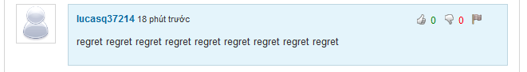

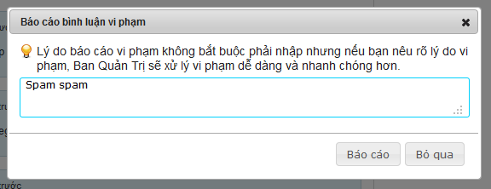

**Button / Hyper links**

|  |  |  |  |  |
| --- | --- | --- | --- | --- |
| **Function** | **Description** | **Available Criteria** | **Validations** | **Outcome** |
| Report a comment | This button is displayed with flag symbol and it is used to report a comment | Only available when move mouse to other user’s comments | No validation | Popup report window for enter reason |
| Vote up | This button is displayed with thumb up symbol and it is used to vote up for a comment | It will be showed when user move the mouse pointer to a comment | No validation | Vote up number is increased by 1, thumb up symbol turn into green |
| Vote down | This button is displayed with thumb down symbol and it is used to vote down for a comment | It will be showed when user move the mouse pointer to a comment | No validation | Vote down number is increased by 1, thumb down symbol turn into red |
| Post a report | This button is used for post a report to the system | Always available with popup | No validation | Popup a message “Báo cáo vi phạm hoàn tất! Ban quan trị sẽ kiểm tra lại trong thời gian sớm nhất.” |
| Cancel posting a report | This button is used for cancel reporting and close the popup | Always available with popup | No validation | Popup closes |

# References